TRADE FAIR PREVIEW FOR PUBLICATION
GEZE at FENSTERBAU FRONTALE 2018
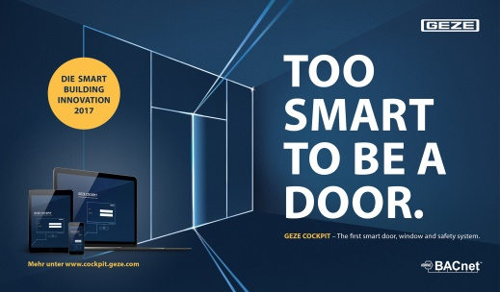
21 - 24 March 2018, NürnbergMesse, Hall 2, Booth 2-424

Leonberg, 2 February 2018

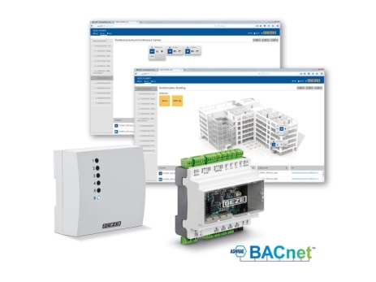
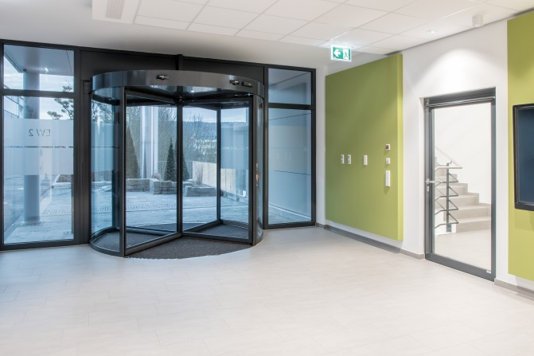

The new BACnet building automation system GEZE Cockpit makes buildings really smart. Doors and windows
can now also be integrated into a building system, and operated and monitored from a central location.

Photos: GEZE GmbH

Smart façades. Made by GEZE.

Heating, lighting, ventilation, and climate control systems: all of them are great and, of course, useful. But buildings only become really smart (meaning complete, safe and efficient) when doors and windows are also automated and integrated into the building system. At the Fensterbau Frontale trade show, GEZE will once again present new and innovative solutions from the fields of door, window and safety technology as well as building automation.

Professional solutions: Intelligent solutions for doors and windows
One of the highlights on show at the trade fair will be GEZE Cockpit: The new BACnet building automation system makes buildings really smart, since it now allows automated doors and windows to be integrated into a single building management system. Thanks to interdisciplinary networking in Smart Buildings, GEZE Cockpit offers new options for convenient, secure, and energy-saving building operation. The system's unique advantages are the central visualisation, operation and monitoring of automated GEZE products for door, window and safety technology. It can be used as an independent system, or integrated into a higher-ranking building control system. GEZE Cockpit improves the comfort, security and energy efficiency of our work and home environments. Further illustrative information can be found here: www.cockpit.geze.com

Networked into GEZE cockpit, and therefore centrally controllable, GEZE presents the F/R-IS/TS variant of the revolving door drive system Powerturn, a unique and complete multifunctional solution with an automated and a manual door leaf. Featuring the multi- award-winning ‘strong’ Powerturn drive, and proven GEZE door closer technology, the door system combines remote operation and monitoring with barrier-free and secure door comfort, emergency exit protection, fire protection and increased burglar resistance. The headstock cover, which extends consistently over both door leaves, creates a perfect look.

GEZE also has new products in door closer technology. A new version with high end closing force ensures the safe closing of doors even when there is limited space or an unfavourable environment, e.g. in the airlock areas of multi-storey car parks. The banging of doors is prevented – without additional dampers. Hold-open systems from GEZE can be supplemented with a new radio component. The new solution is ideal for retrofitting ceiling fire detectors.

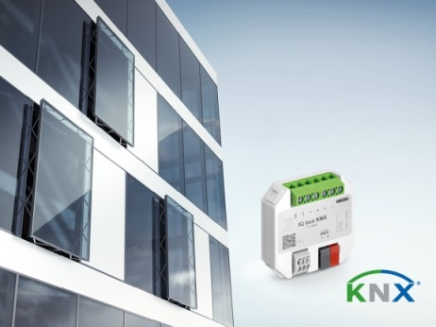
Automated, networked windows create façades that adapt to the climate. For controlled, natural ventilation, GEZE will be presenting façade windows with drives from the IQ window drives range. The new generation of Slimchain 230V chain drives is particularly slim. Installation and commissioning are now even faster and easier. The IQ box KNX interface module enables windows to be connected as direct bus participants in a KNX building system, and be monitored and managed ‘smartly’.

The window drives from the GEZE IQ window drives range can be integrated into
KNX building systems via the IQ box KNX interface module.

Photo: GEZE GmbH

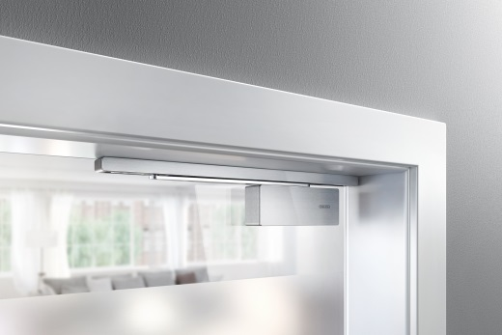

Living Solutions: New door comfort with GEZE ActiveStop

GEZE presents the new version fitted on the frame of the GEZE ActiveStop door damping. The system ensures controlled, dampened opening and closing of interior doors. This version fitted on the frame can simply be adhered into position, and then removed again. During live installations at the GEZE trade fair booth, visitors can see for themselves how easy the retrofit version is. Like the door integrated version, it has already received two awards.

The new GEZE ActiveStop door damping also
received a significant design award for the version fitted on the frame.

Photos: GEZE GmbH

Service Solutions: Work more easily with GEZE service tools
GEZE presents new tools that facilitate the work of installation companies and planners. One of them is WinCalc. The configurator for window technology makes the selection of the optimal window drive easy. The new, more advanced version WinCalc 2.0 can be operated even more intuitively. Among other things, it offers advanced calculation options and a shortened calculation method.

