PRESS RELEASE FOR PUBLICATION

Leonberg, 12 October 2016

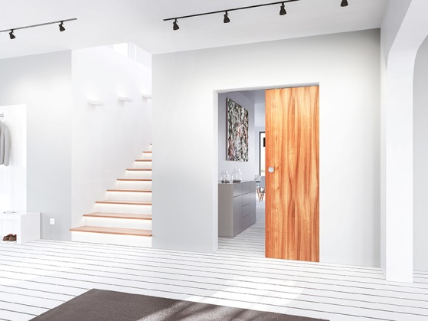
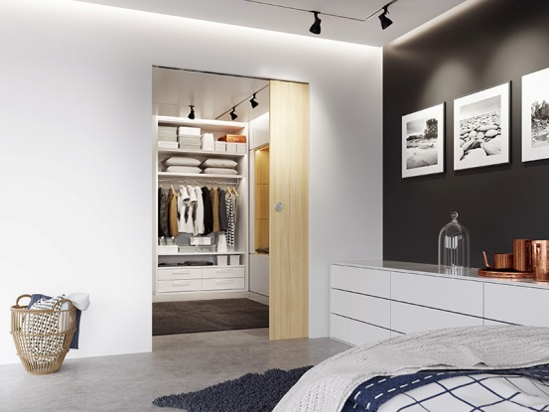

Whether for 40 or for 80 kilogram sliding doors – the GEZE Rollan 40 and 80 NT fitting system heralds a new generation of interior design.

Images: GEZE GmbH

Rollan 40 and 80 NT sliding door system: proven fitting with new details

The GEZE Rollan NT fitting system is the smart solution for 40 or 80 kg sliding doors in living spaces. With its new, particularly light-running roller carriages, the system is even easier to move. A further innovation is the one or two-sided draw-in damper: it can easily be retrofitted to Rollan 80 NT sliding doors with leaf weights of up to 40 kilograms.

As a partition wall or to separate walk-in wardrobes, for example: the new variants of the GEZE Rollan NT fitting system are smart solutions for interior sliding doors. While the Rollan 40 NT moves door leaves with a weight of up to 40 kilograms, the Rollan 80 NT also opens sliding doors with a leaf weight of up to 80 kilograms. And it does so exceptionally easily and quietly. The new fitting system roller carriages make this possible: thanks to the low initial friction (< 25 N), the fitting can also be used in rooms that are required to offer accessibility for all. If desired, the Rollan 80 NT version can be fitted with a draw-in damper to door leaf weights of up to 40 kilograms – without restrictions in terms of leaf width. The Rollan 80 NT SoftStop can be used one-sided or double-sided, and also increases sliding ease and safety.

Installation of the draw-in damper is simple and quick: no changes to the door leaf or alterations to the existing installation situation are required. Installation is also easily performed on existing Rollan fitting solutions: the track does not have to be replaced in order to install the new roller carriages and the optional draw-in damper retrospectively. This reduces the installation time – simple, efficient and convenient.

Press contact:  Julia Graf  Tel.: +49 (0) 7152 203-505  j.graf@geze.com  Fax: +49 (0) 7152 203-237 | GEZE GmbH  Reinhold-Vöster-Str. 21-29  D-71229 Leonberg  www.geze.com

About GEZE
The GEZE brand stands for innovation and for top quality products, processes and services. GEZE is one of the leaders in the global market and it is a reliable partner worldwide for door, window and safety technology products and systems. No matter what the requirements of a building are – GEZE implements optimum solutions and combines functionality and security with comfort and design. GEZE door closers open up numerous technical and visual possibilities. Every day, millions of people go through doors equipped with the overhead door closers from the TS 5000 series and enjoy the comfort of automatic door systems, e.g. the Slimdrive range. Barrier free door and window systems provide greater comfort, not only for people with restricted mobility. The glass systems and fitting solutions for the attractively designed sliding systems are the ultimate in design aesthetics. GEZE also offers a wide product range in the field of window and ventilation technology. Complete "intelligent" smoke and heat extraction solutions (RWA) and a comprehensive selection of door systems for RWA air supply solutions are also available for preventive fire protection. GEZE's safety technology includes escape and rescue route solutions, lock technology, and access control systems. The GEZE building management system provides an overview of a building's entire technical facilities. With its systems expertise, GEZE creates coordinated system solutions which combine individual functional and safety requirements in one intelligent system. GEZE product solutions have received numerous awards and can be found in renowned structures all over the world. The company has a global presence with 31 subsidiaries, 27 of which are outside Germany, a flexible and highly efficient sales and service network, and almost 2,800 employees. In the 2014/2015 fiscal year, GEZE achieved a turnover of over 366 million euros. www.geze.com

